**Angular Application: COVID APP**

**DASHBOARD COMPONENT**

As the application starts dashboard will be the starting point of application. User will be landed to see State details at the start. Different state with details of confirmed, active, recovered and death details are shown.

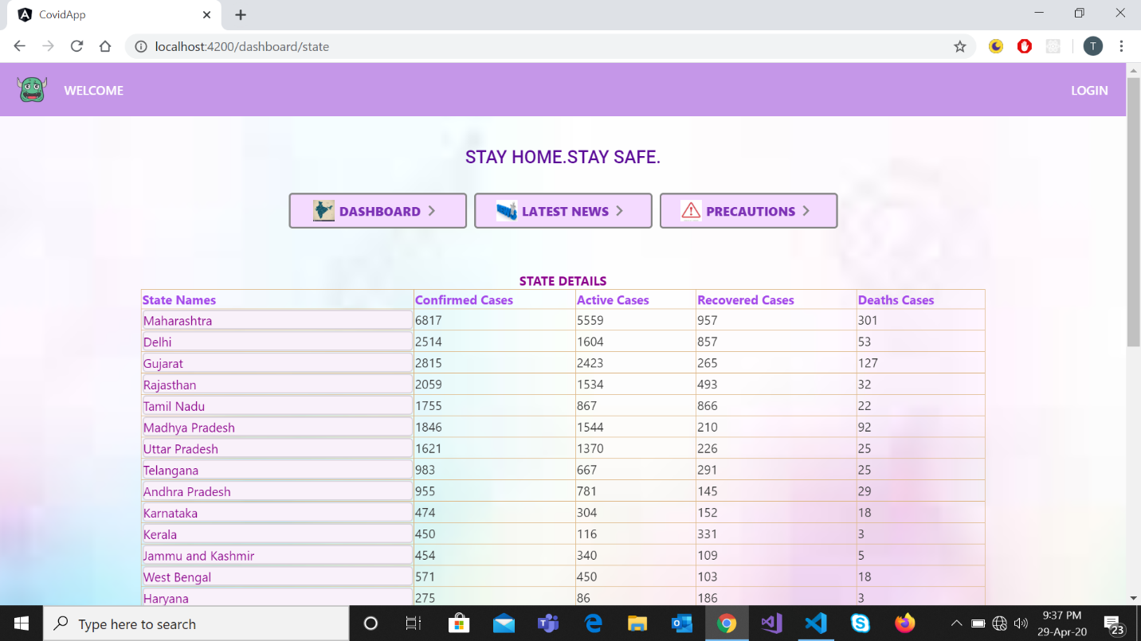

On hovering on any state animations works and selected state is highlighted.

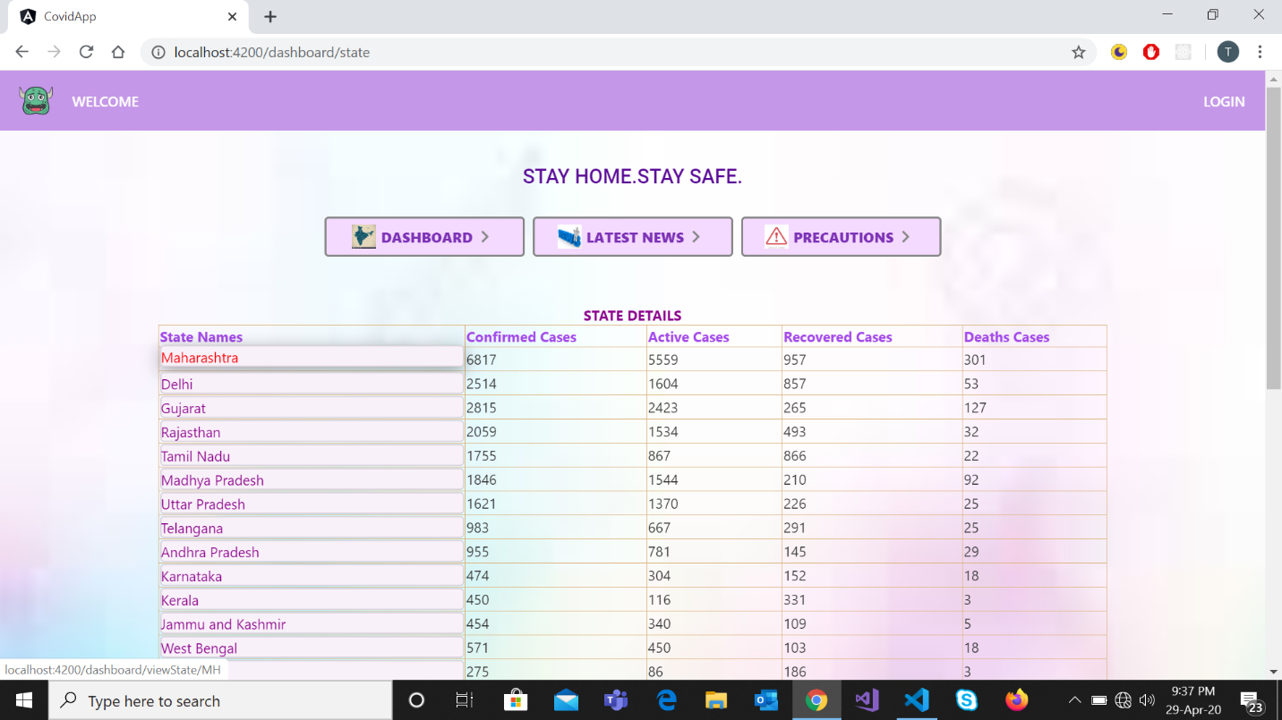

After clicking on any state name, its district details are shown.

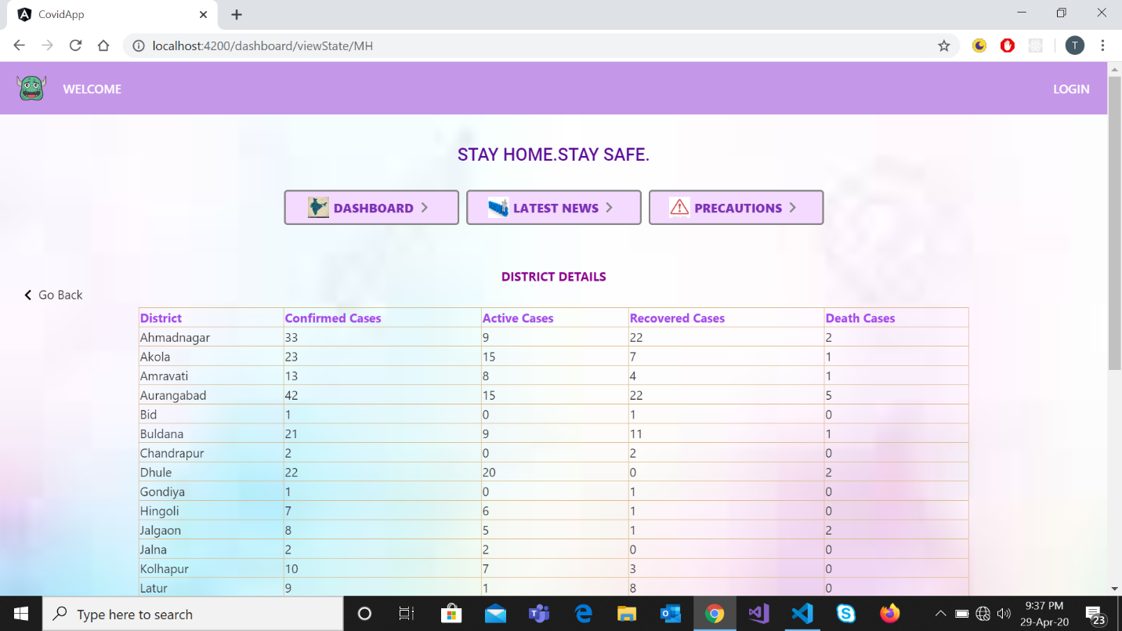

On pressing “Go Back” or “Dashboard” tab the user is again landed to dashboard page with state details.

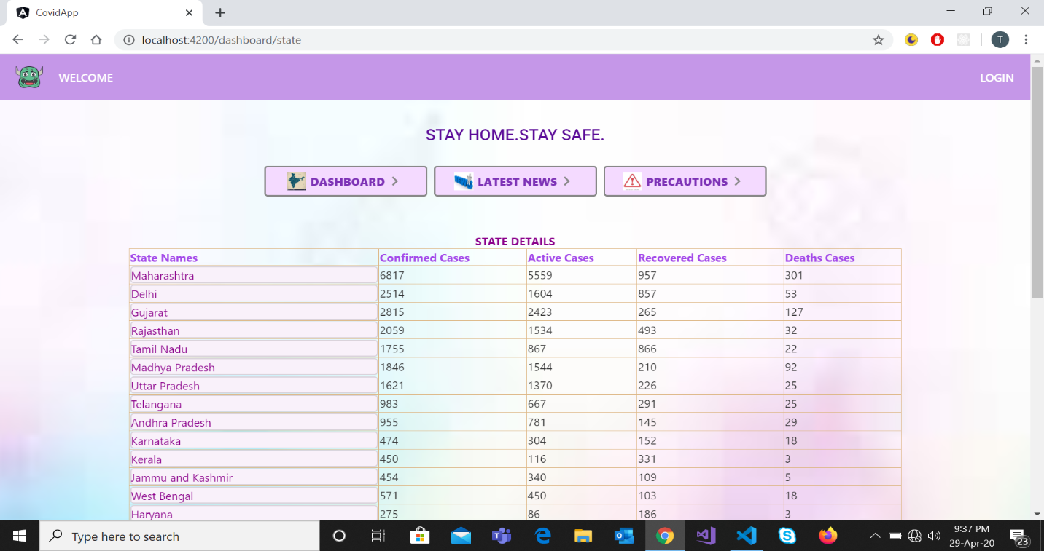

And if there is a state which is not having any case related to Corona pandemic then clicking on that state name, district page is not showing any records.

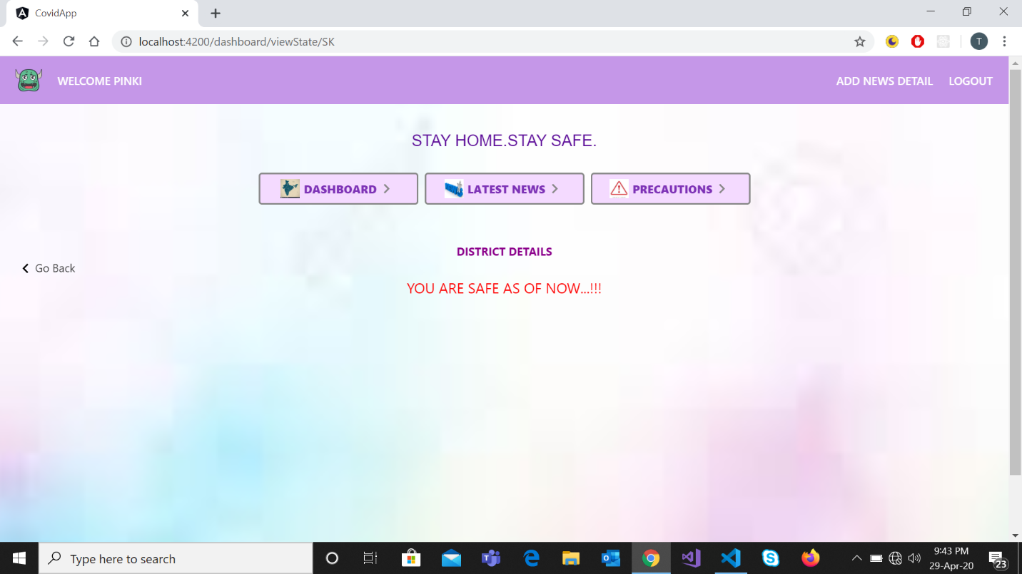

**LOGIN COMPONENT**

On clicking on “LOGIN” the user is landed to login page to verify the credentials.

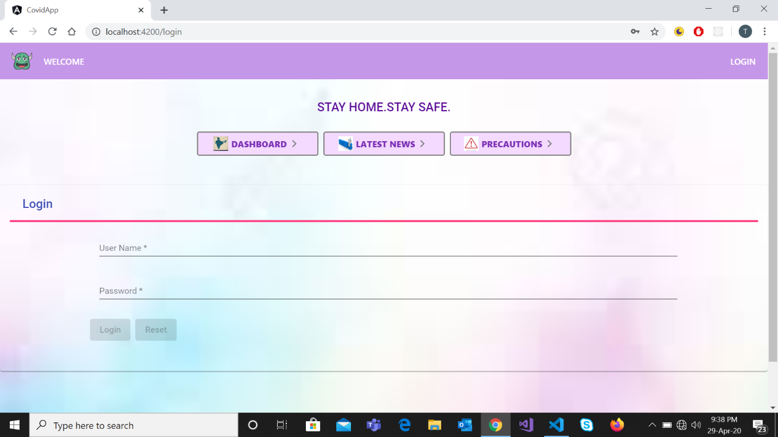

And if the credentials are wrong the error message is shown and form is reset.

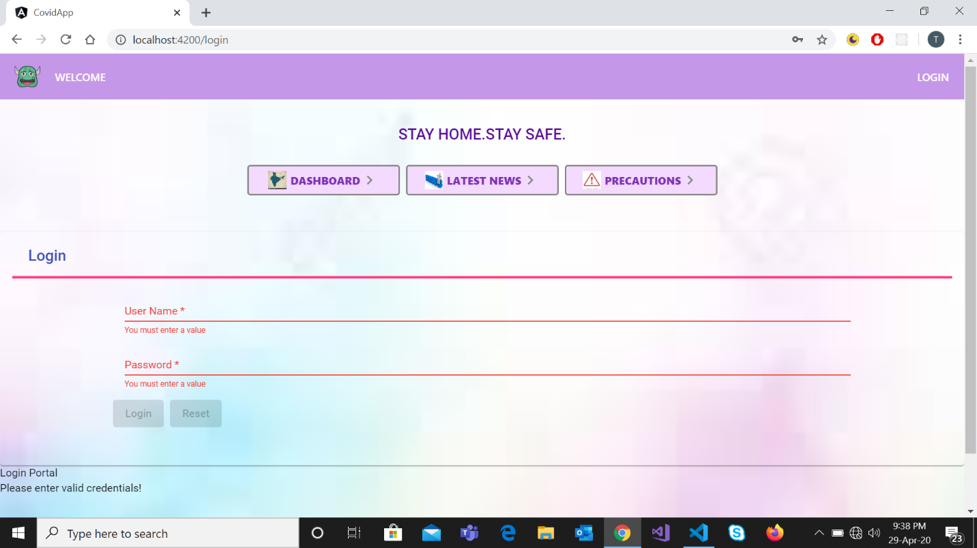

After successful login the user is landed to news details page to add new news details. After Login the “ADD NEWS DETAILS” link is provided at the top for authenticated user to add news details. Also the login user name is rendered at top.

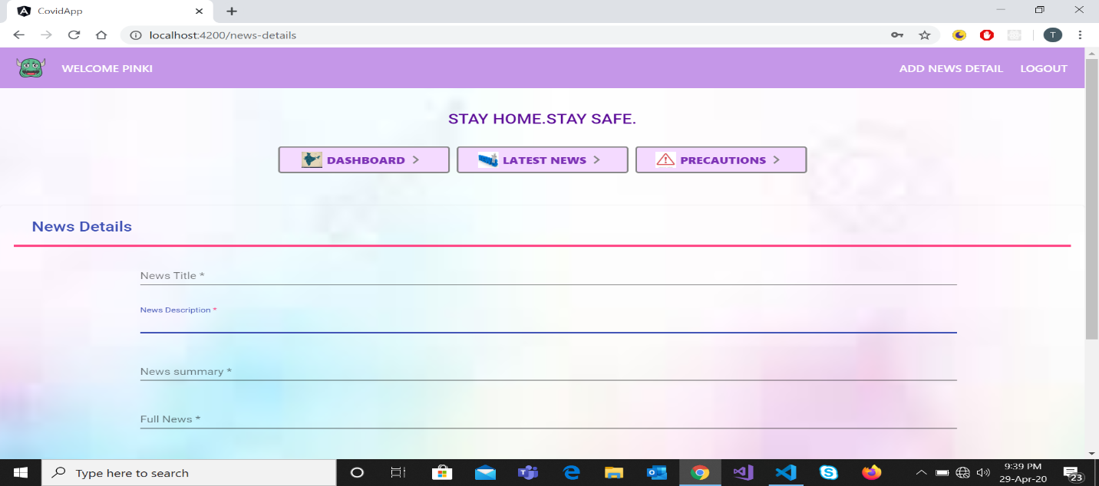

**LATEST NEWS COMPONENT**

After adding the news details user is landed to latest news page where he can see the newly added news.

Latest news contains the news posted by the authenticated user which is visible to every normal user.

If the user again want to add any news then the user can user the “ADD NEWS DETAILS” link given in the menu bar.

And clicking on the link user will be redirected to the add news details page where user can add the news details.

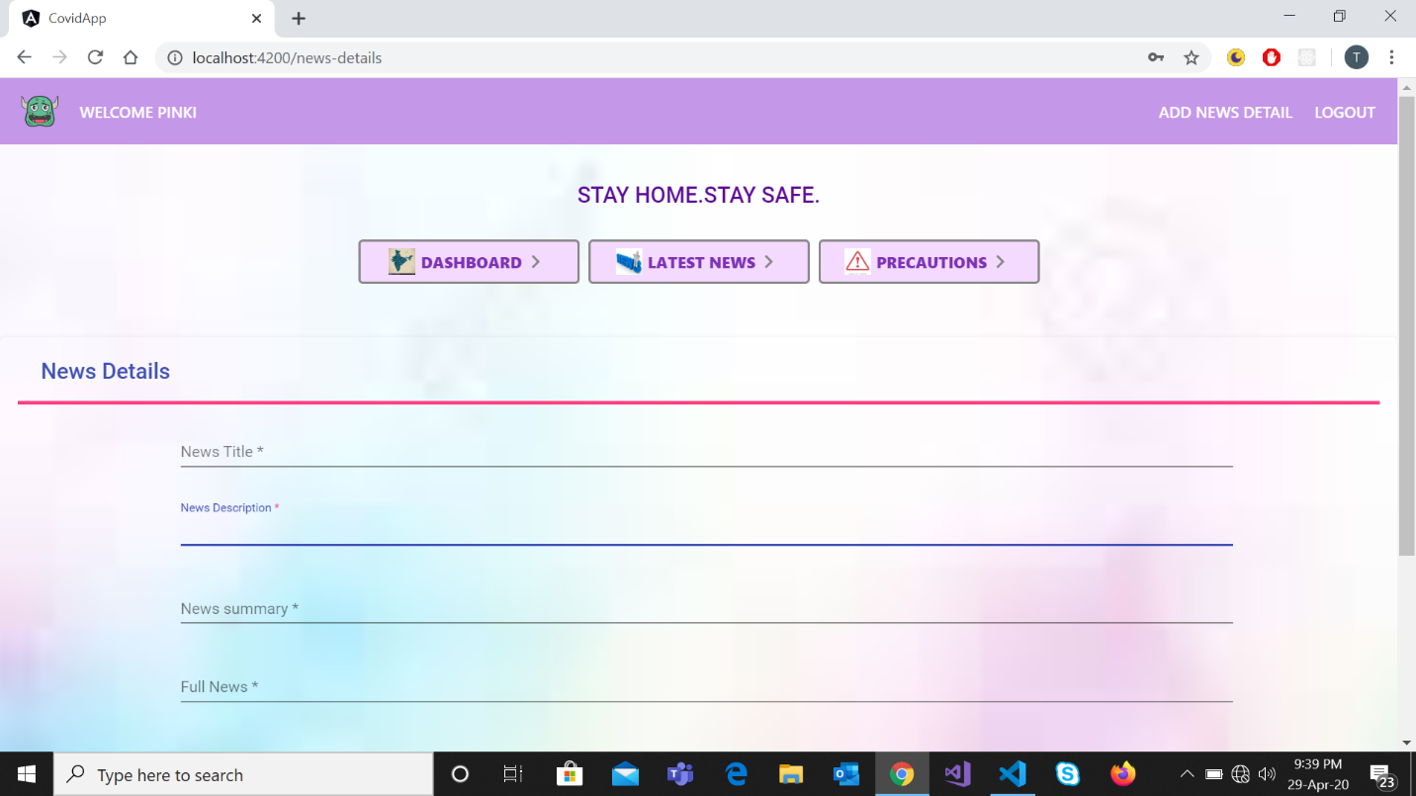

On Clicking the latest news tab the general user is landed to news page where he can see the news posted by the authenticated user.

**PRECAUTIONS COMPONENT**

On clicking on “Precautions” tab the user is landed to precautions page where general preventions are posted with some images having some animations effects.

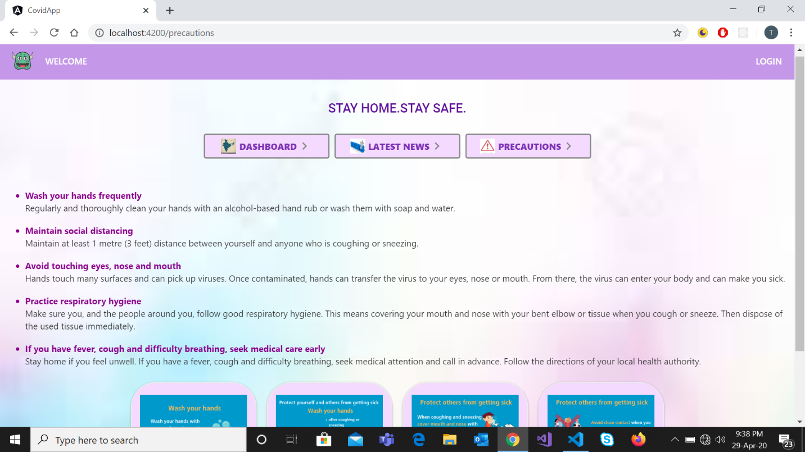

Images are shown in the lower portion with some preventive measures written.

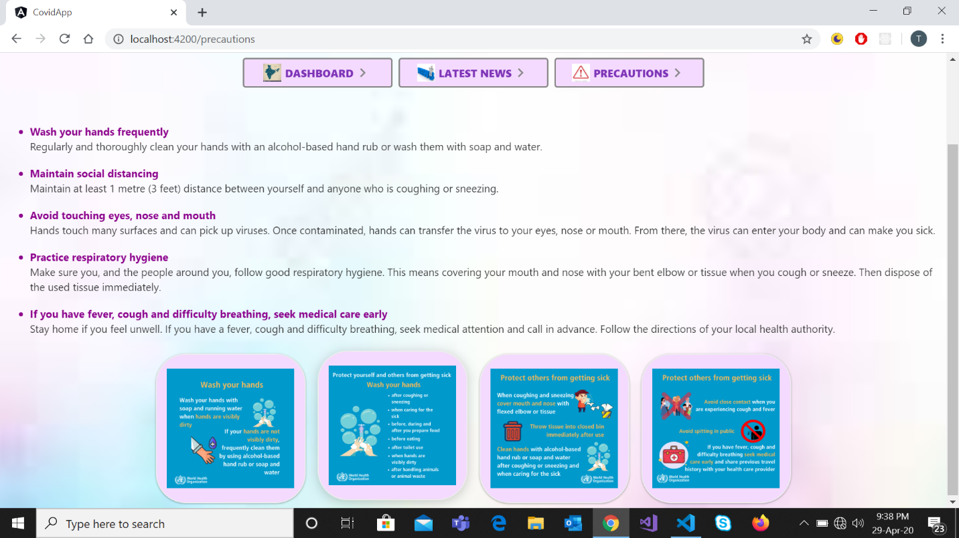

SESSION MANAGEMENT

If the user is logged in and refresh the browser the user still remains logged-in.

**LOGOUT**

After clicking the logout button user is landed to dashboard page where state details are shown and now no “ADD NEWS DETAILS” link is there as only authenticated user are able to add news. No name is rendered at the top.



**TEST CASES RESULT**

**SURGE DEPLOYMENT**

App is deployed successfully on surge.

